Fecha:
L..O. to recognise phrases for weather in Spanish. To answer a question about the weather in Spanish.
Relaciona las fotos con el tiempo.
hace frío

hace calor

está nublado

está nevando

está lloviendo

hace viento

hay tormenta

hace sol
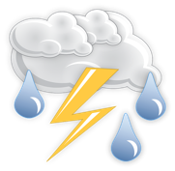
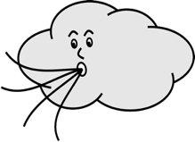

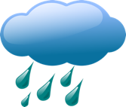

¿Qué tiempo hace hoy?

Hoy _________________________________________________

Thank you for downloading my resource!

If you have any feedback or resource requests, please contact me at
theprimaryspanishclassroom@gmail.com

To find more Spanish resources, please visit my shop.
https://www.tes.com/teaching-resources/shop/TheSpanishClassroom

You can also find ideas and inspiration for Spanish teaching at my Instagram account:
https://www.instagram.com/primaryspanishclassroom/

