el gato negro | la calabaza | el monstruo
la bruja | 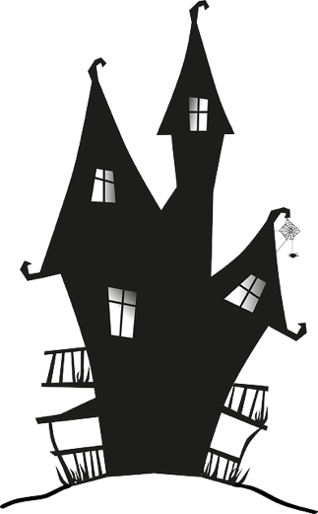  la casa encantada | el fantasma

el gato negro | la calabaza | el monstruo
la bruja | la casa encantada | el fantasma

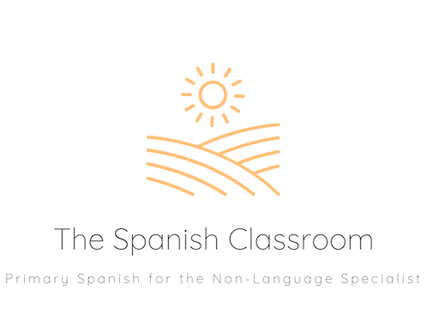

Thank you for downloading my resource!

If you have any feedback or resource requests, please contact me at
theprimaryspanishclassroom@gmail.com

To find more Spanish resources, please visit my shop.
https://www.tes.com/teaching-resources/shop/TheSpanishClassroom

You can also find ideas and inspiration for Spanish teaching at my Instagram account:
https://www.instagram.com/primaryspanishclassroom/

