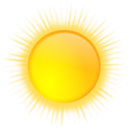 | 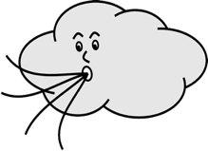 | 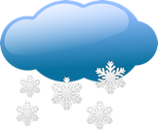 | 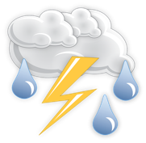
hace sol | hace viento | está nevando | hay tormenta

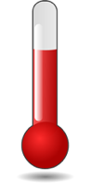 | 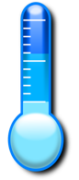 | 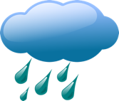
hace calor | hace frío | está lloviendo | está nublado

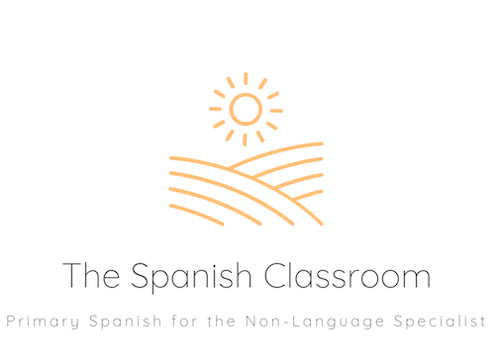

Thank you for downloading my resource!
If you have any feedback or resource requests, please contact me at
theprimaryspanishclassroom@gmail.com

To find more Spanish resources, please visit my shop.
https://www.tes.com/teaching-resources/shop/TheSpanishClassroom

You can also find ideas and inspiration for Spanish teaching at my Instagram account:
https://www.instagram.com/primaryspanishclassroom/

